IE 466 – Group HSnP
The Pennsylvania State University
Fall 2025
Due Date: Dec 1, 2025
Team HW#5 – Prototype, Feedback, and Redesign Recommendations
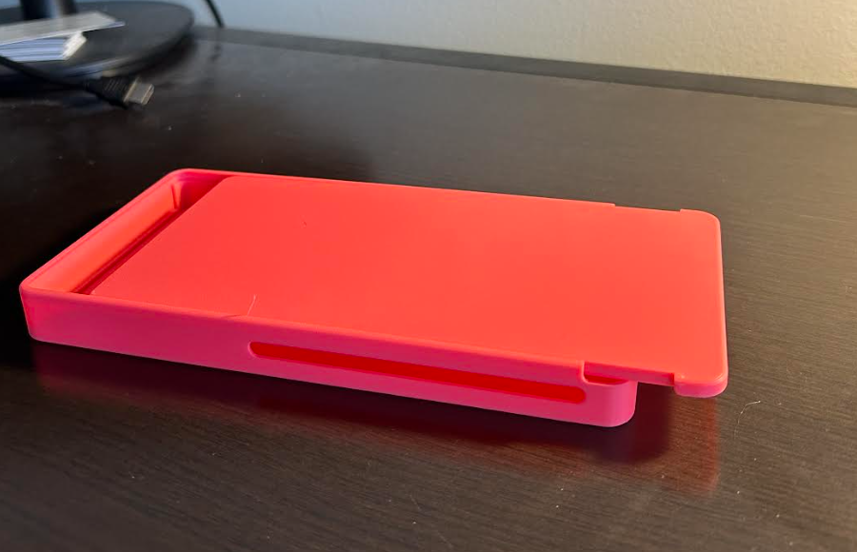
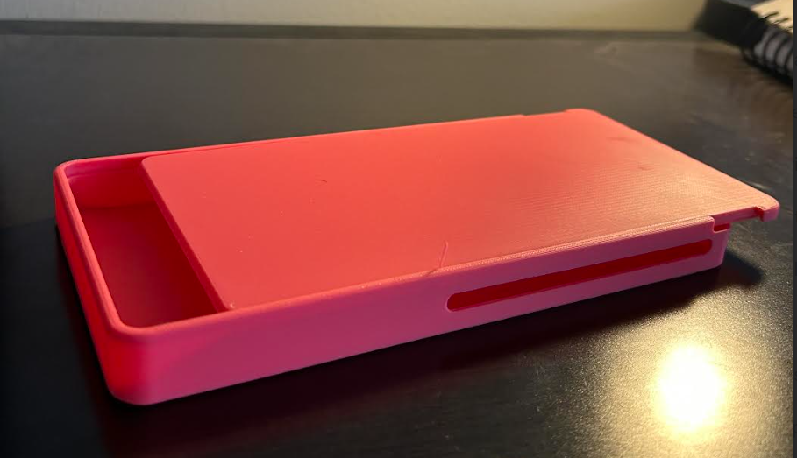
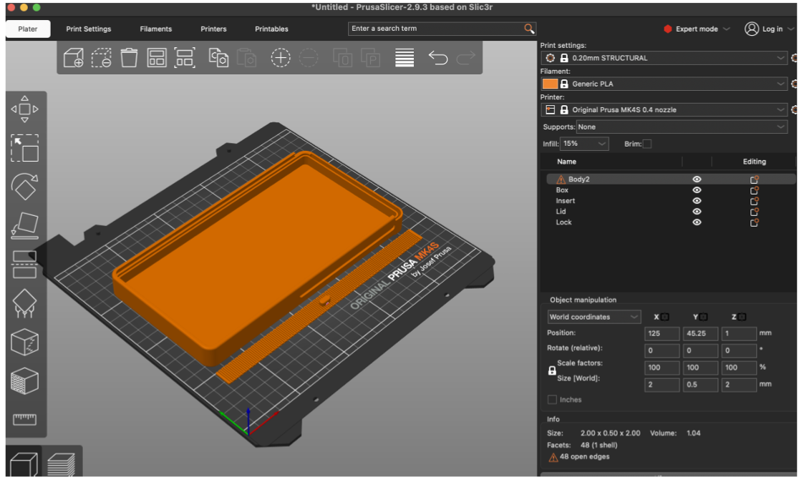
During user testing, we reached out to four classmates outside our team to evaluate our prototype. We looked at three main things while conducting user testing, which were practicality, usability, and the overall value of our phone lockbox. Testers liked the idea and said that the device could genuinely help with studying, self-care routines, and reducing screen time. The first piece of feedback we received was that our design felt too broad, and that trying to support different use cases made our product harder to understand. Second, testers noted that having four separate parts made the lockbox feel more complicated to assemble, and the locking mechanism was complicated. Finally, users suggested that we define our target market to focus on design features more effectively.
If we had more time to work on the project, we would have done deeper market research to define our primary users and shape the product around their needs. Based on this, we would redesign the lockbox to reduce the number of components from four to two. This would make it easier to manufacture, more intuitive to use, and durable. This improved design would build a strong product image and make it feel built for purpose rather than being general.

